

PRogramming Fundamentals

# Lab Assignment #6

## Name: Muhammad Hussain Javed

## Roll Number: 21K-3584

***Question #1)***

In Cryptographic algorithm, one of the most renowned techniques is system of congruence. According to this system the two numbers are congruent, if and only if their mod with some number is same. Write a C program to check whether two numbers are congruent.

**a mod z** is congruent to **b mod z** if and only if they are equal.

The console should look like this:

|  |
| --- |
| Enter a number a :  2  Enter a number b:  14  Enter a number z:  12  Output:  **2 mod 12 and 14 mod 12 are congruent.** |

Answer 1)

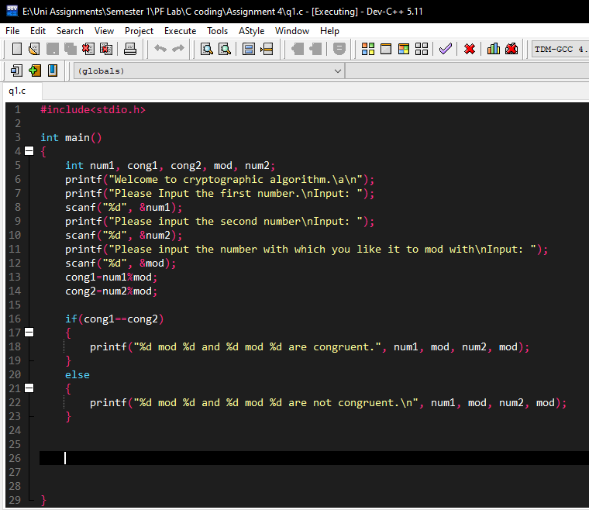

Output:

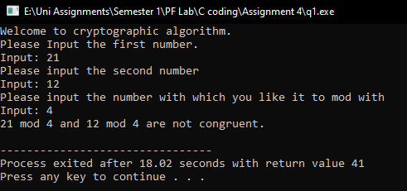

Question #2

***An electric power supply company wants to design and automatic system for calculation of the bills. The conditions for the bill calculation are provided below:***

|  |
| --- |
| * ***If Units <300 then charge 8rs per unit. Tax applied would be 10%*** * ***If Units >300 and less than 600, then charge 8rs per unit for first 300 units and charge rs 12 for other units which are above 300 and below 600. Tax applied would be 12%.*** * ***If units are 600+, then you would charge 15rs per unit and tax applied would be 15%.*** * ***In last calculate net bill using nested if.*** |

Answer 2)

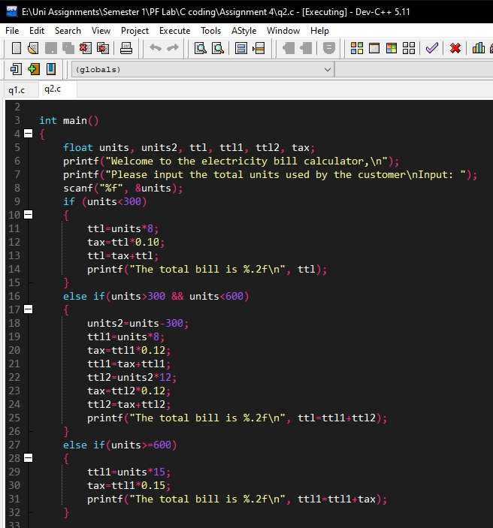

Output:

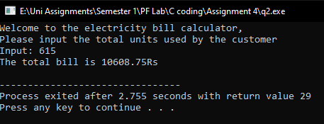

Question #3

.

Comment whether above problem can be solved using Switch/ Nested Switch or not. Also explain your answer with valid points.

Answer 3)

Question 2 cannot be solved using nested switch because when the user will input the units, more than 600 cases would have to be made in order to calculate the electricity bill. Switch can be used as outer condition where it will take the input that if the unit are less than or greater than 600 then match them with the case.

## Question #4

*Write a C program to ask the user, that whether he wants to find min/max, for min/max use an integer and take 0 for min and 1 for max from user. Then ask user the two number and find the min/max of the two number using ternary operator.*

Answer 4:

Source Code:

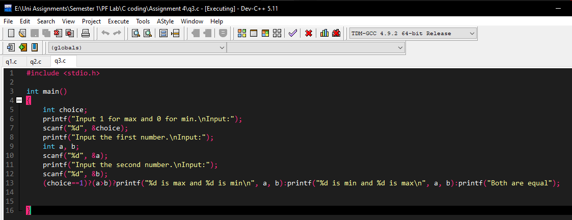

***Output 1:***

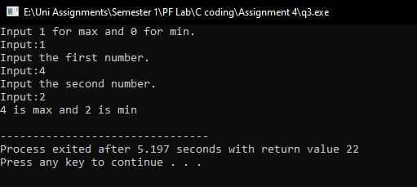

Question #5

***Use the following departmental hierarchy chart of employees and implement this using nested switch statement in C. The main Manu should shows subordinates of Thomas Edison which Marrie Currie, Blaise Pascal and Isaac Newton. When Select the Marrie Currie It should show subordinates of her and same stands for others.***

***Note: Use integers was the switch case.***

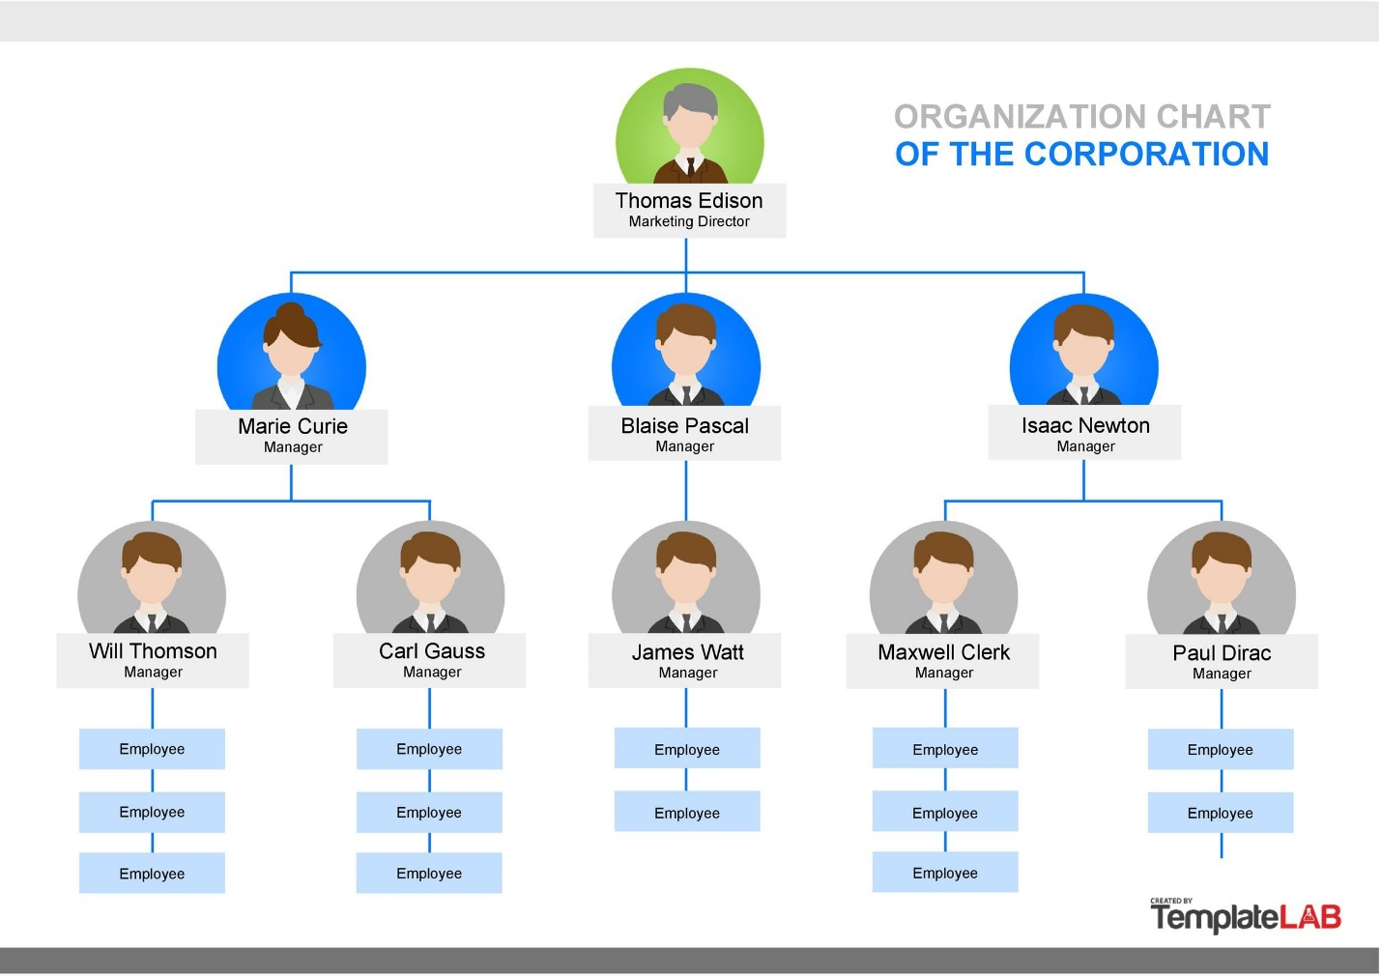

Answer 5:

***Source Code Part 1:***

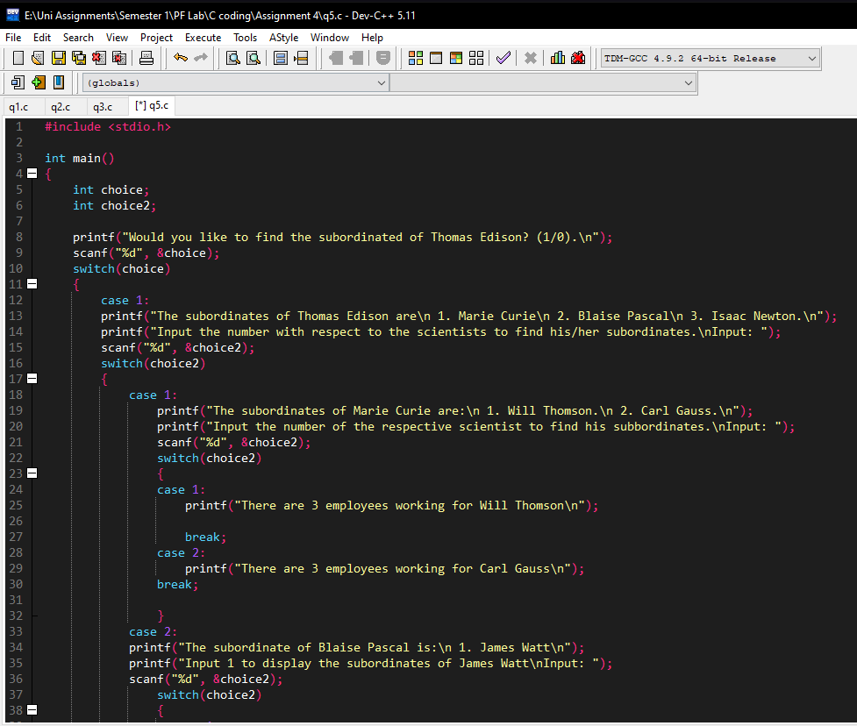

***Source Code Part 2:***

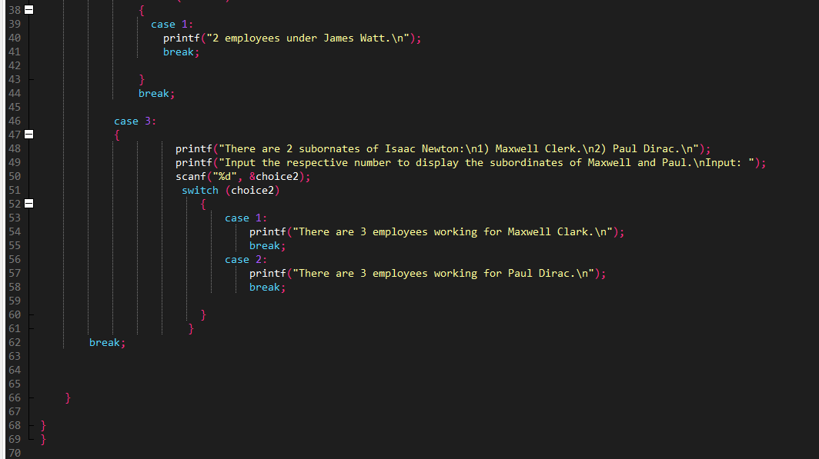

***Output:***

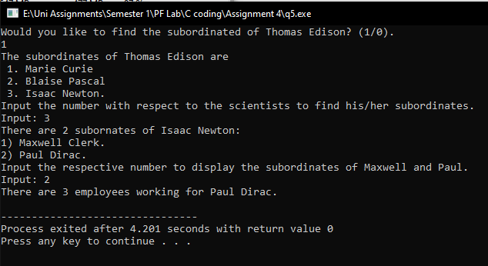

Question #6

*Implemented above using nested if*

Answer 6:

Source Code Part 1:

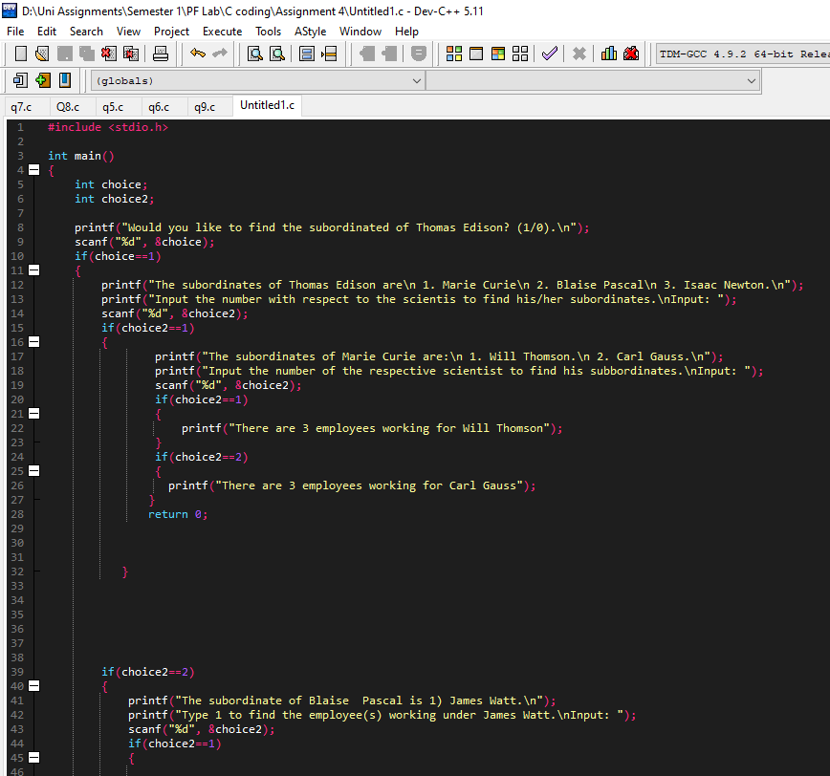

Source Code Part 2:

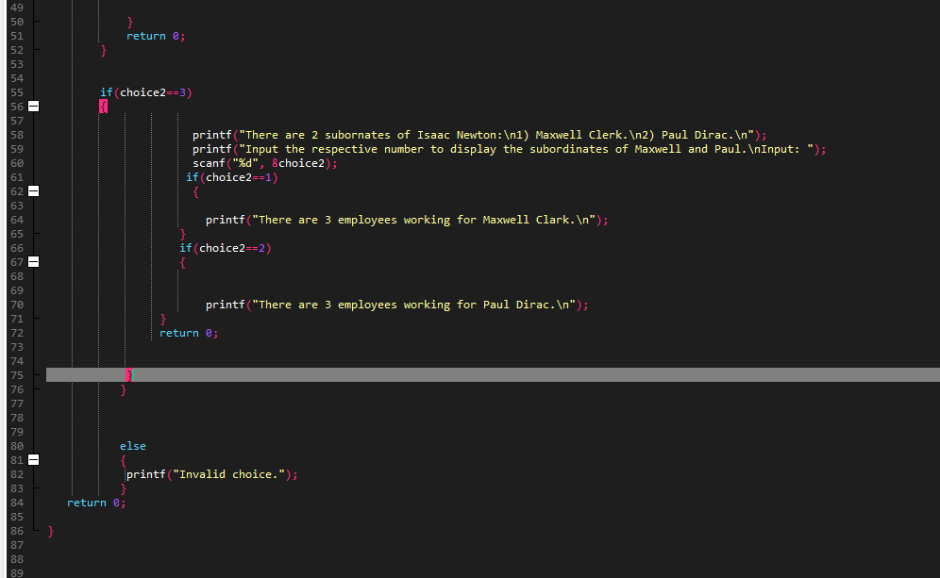

Output:

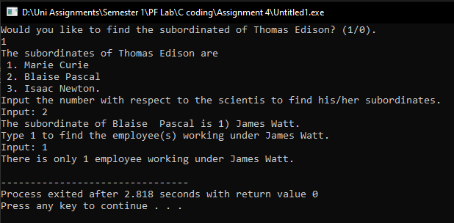

Question #7

*Implement above using if as outer conditional and switch as inner conditional.*

***Source Code Part 1:***

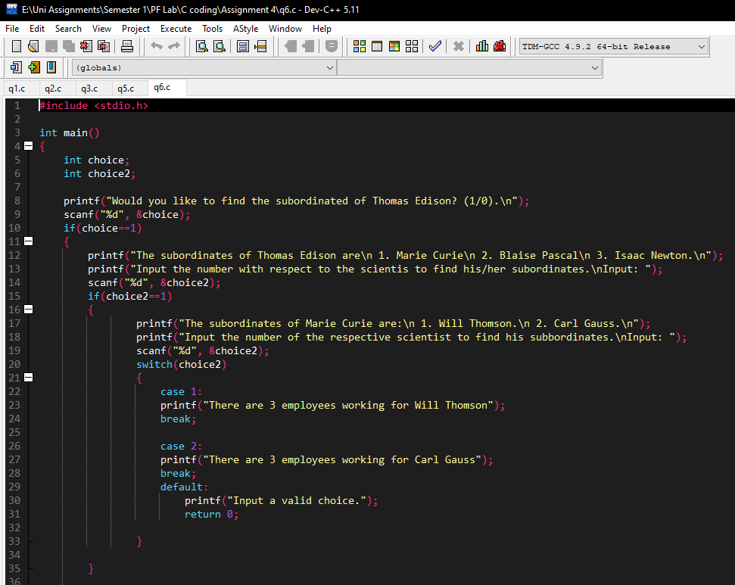

***Source Code Part 2:***

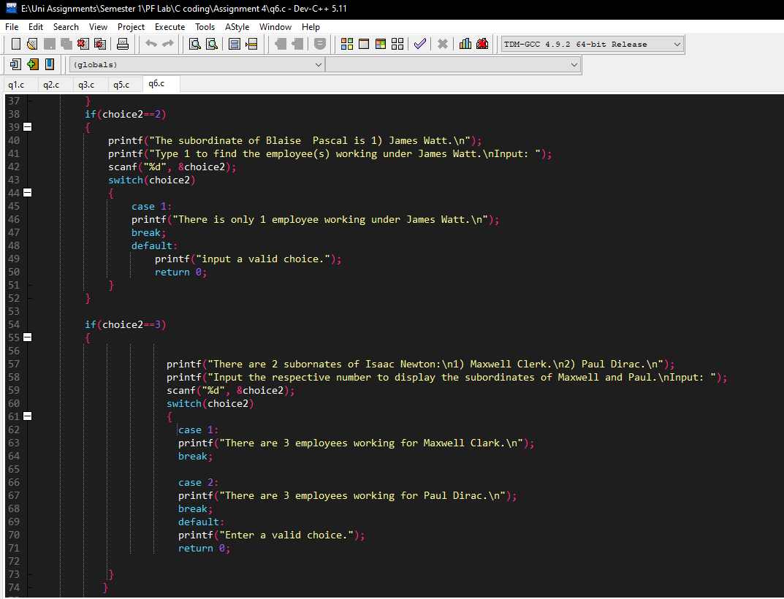

***Output:***

Question #8

Implement above using switch as outer conditional and if as the inner conditional.

Answer 8)

Source Code Part 1:

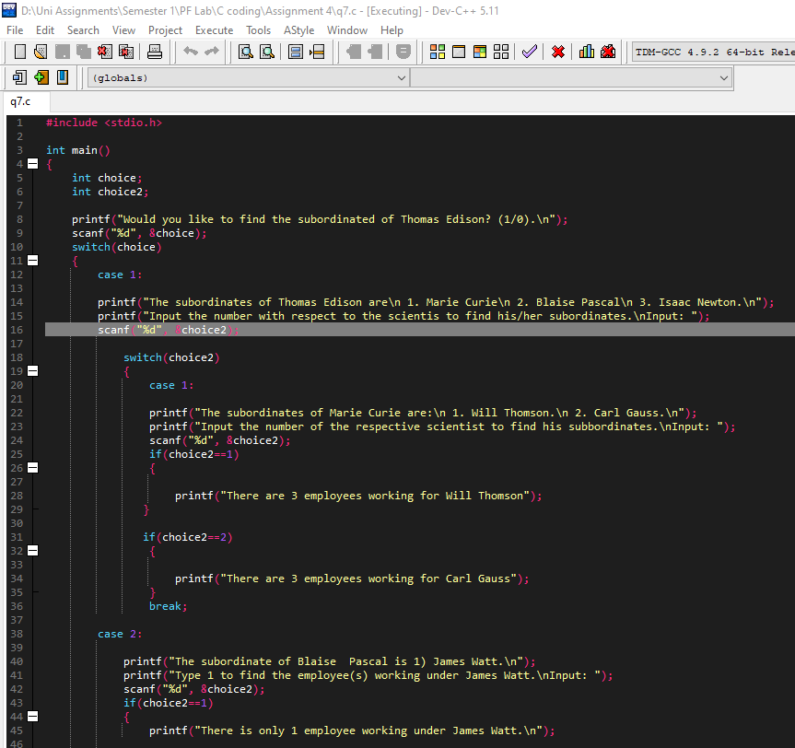

Source Code Part 2:

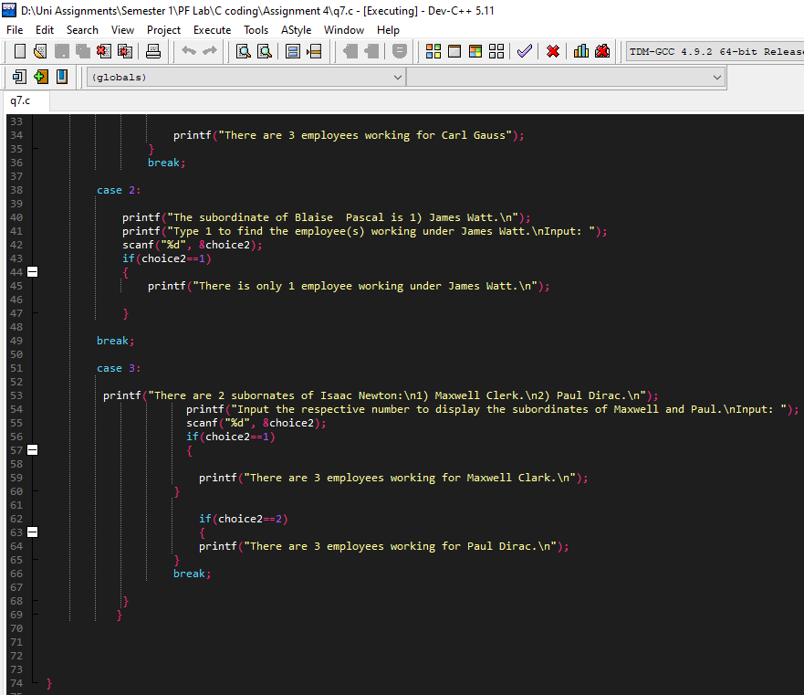

Output:

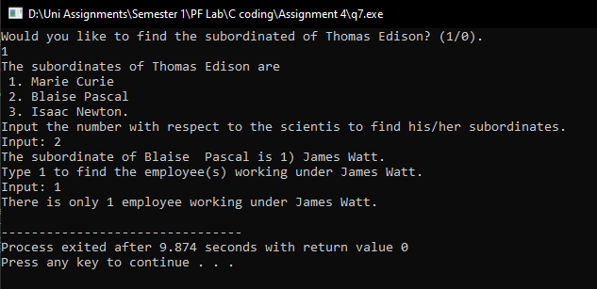

Question #9

Alice and Bob want to exchange the 4- digits message on the internet, but they want to ensure the security. They went to a cyber security specialist Edwin for the solution. Edwin listened to the requirement of the clients and proposed a scheme for cryptography, which is first of all the algorithm would reverse the message, after reverting the message, it would determine an alphabetic character against the digit. For example for 0 it would be A, for 1 it would be B, for 2 it would be C, for Z it would be 25.

Write a code in C for the above cryptographic algorithm using nested decision structures in C for Edwin.

The samples are like:

|  |  |
| --- | --- |
| Input String | Cypher Text |
| 1546 | GEFB |
| 7777 | HHHH |
| 5555 | FFFF |
| 1234 | EDCB |

Answer 9)

***Source Code Part 1:***

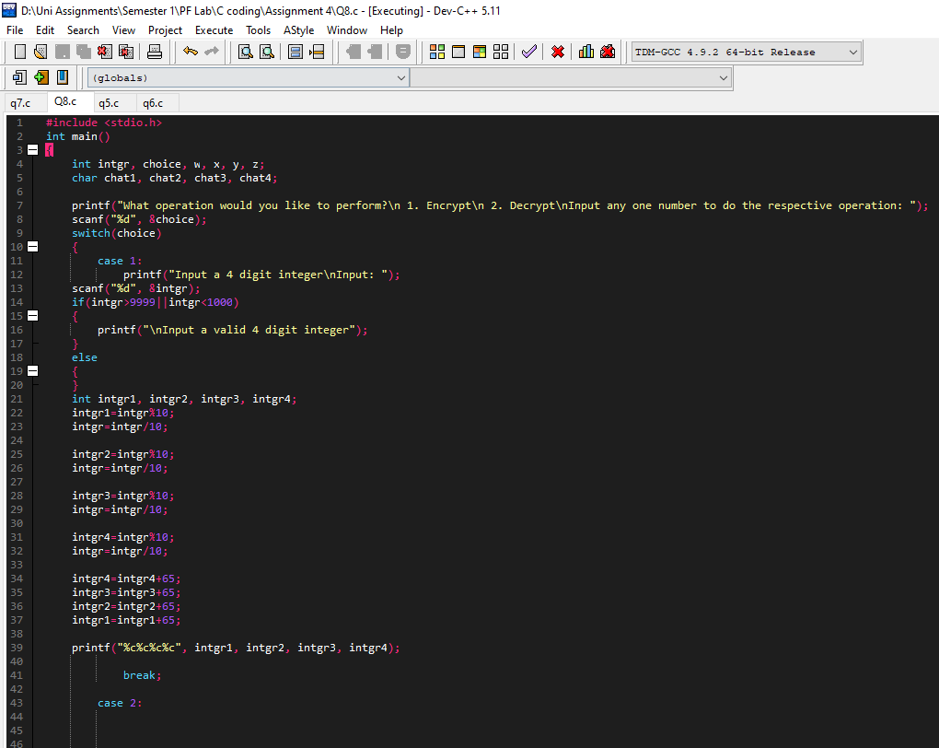

***Source Code Part 2:***

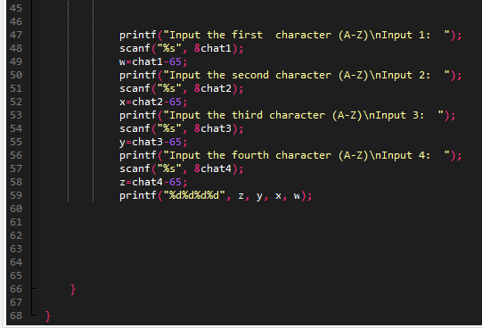

***Encryption:***

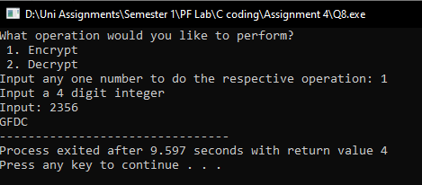

***Decryption:***

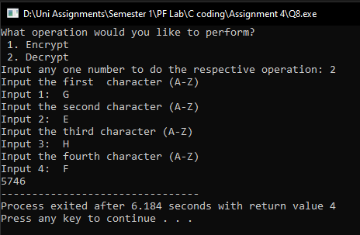

Question #11

Guass, who is a watch man at the Mac’s Casino is frustrated from the people, who enter the Casino without having a membership. He went to Fredrick, a Cyber Security Specialist and discussed his issue with him. Fredick is master of mathematics and Cryptographic algorithms, so he proposed an automated system for entry of the members. Which is totally based upon logic. The system would show randomly a 4-digit message on the screen and after reading the message user would type the output.

**The main process would be:**

User would read the message from screen and would add (1 if he is male and, 0 if she is female) Furthermore, he/she would add age to the input. After this the user would add all the digits of the input and finally take remainder with 5 of the output.

This process would be like this:

|  |
| --- |
| **Case 1: The age of the user is 40, and he is male.** |
| Input string is: 3231, he would add 41 to the string then it would become 3272. Then he would add individual digits of the string 3+2+7+2 which would generate 18, finally 18%5 is 3 so the answer would be 3. |
| **Case 2: The age of the user is 15, and he is female.** |
| Input string is: 1000, he would add 15 to the string then it would become 1015. Then he would add individual digits of the string 1+0+1+5 which would generate 7, finally 7%5 is 2 so the answer would be 3. |

Your task is to write a C program using nested decision structures for Guass so that, he can deploy this program for automatic verification of the password. At this level you need to provide the input and output of the code and match the results.

|  |
| --- |
| **Input a 4-digit number**  The user entered 1000,  **Input your age and gender**  The user entered 15 and 0  **Input the verification code**  The user inputs 2  The system says correct, if the user enters other digit, the system would say incorrect |

***Answer 11)***

***Source Code Part 1:***

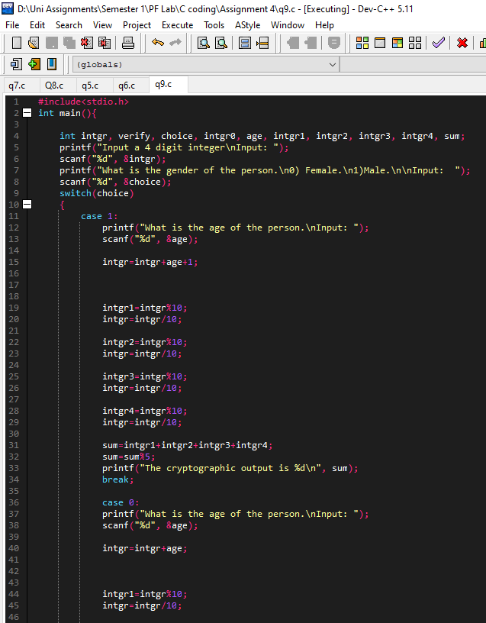

***Source Code Part 2:***

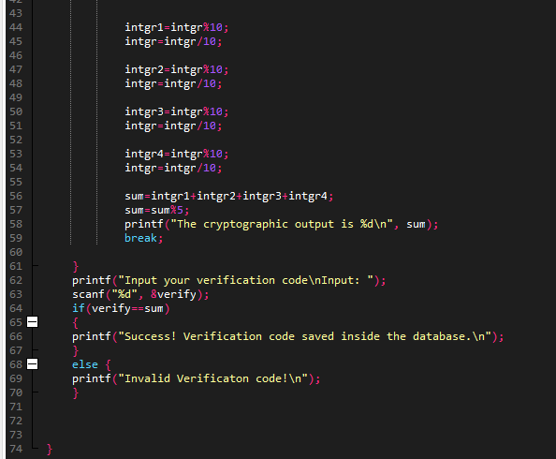

***Output:***

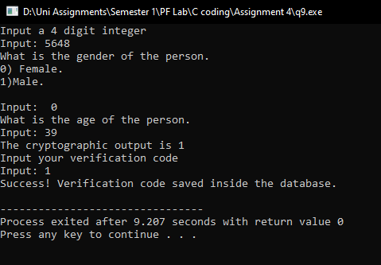

*Document created and compiled by Muhammad Hussain Javed of class BCY-1B.*